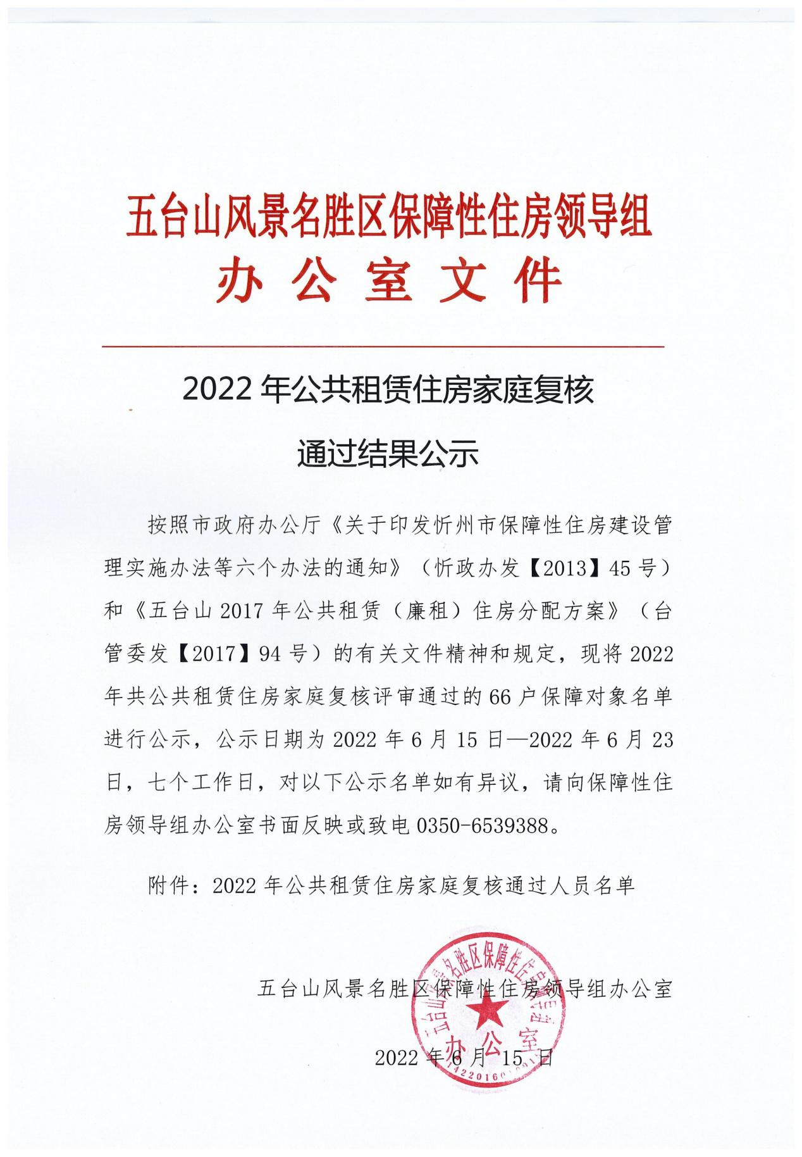

2022年公共租赁住房家庭复核
通过人员名单
序号 | 申请人 | 备注
1 | 张华峰 | 142223********7021
2 | 刘文光 | 142223********8415
3 | 史旭华 | 142223********8410
4 | 卢晨阳 | 142223********3917
5 | 王晓凤 | 142223********7924
6 | 张小明 | 142223********6139
7 | 杨 平 | 140107********223X
8 | 张仁杰 | 142223********0013
9 | 高宏伟 | 142223********1519
10 | 申 娟 | 142223********0920
11 | 刘永珍 | 142223********6726
12 | 白雪琪 | 142223********8421
13 | 韩忠明 | 142223********8418
14 | 张贵良 | 142223********7713
15 | 孙建东 | 142223********7731
16 | 孙跃飞 | 142223********7716
17 | 杨俊文 | 142223********8111
18 | 王 林 | 142223********773X
19 | 杨贵华 | 142223********7717
20 | 王栓林 | 142223********771X
21 | 康云龙 | 142223********8115
22 | 白华龙 | 142223********0911
23 | 任慧斌 | 142223********7710
24 | 史宏平 | 142223********3912
25 | 郑佳欣 | 142223********7724
26 | 高艳红 | 142223********4827
27 | 赵书梅 | 142223********7925
28 | 杨根年 | 142223********7916
29 | 韩近元 | 142223********7915
30 | 田顺义 | 142223********7914
31 | 赵鹏飞 | 142223********7910
32 | 殷风来 | 142223********7918
33 | 芦方桃 | 142223********7926
34 | 胡艮生 | 142223********7915
35 | 李占军 | 140922********0019
36 | 刘 瑞 | 142223********7915
37 | 陈丽俊 | 620102********464X
38 | 李艳杰 | 142223********7911
39 | 孟建伟 | 142223********301x
40 | 孙书香 | 142223********7922
41 | 张金婵 | 142223********7926
42 | 王计珍 | 142223********7925
43 | 罗建军 | 142223********1813
44 | 师尚平 | 142223********0657
45 | 范月峰 | 142223********0019
46 | 罗 强 | 142223********7919
47 | 张建花 | 142223********7912
48 | 杨秀杰 | 142223********8413
49 | 罗瑞清 | 142223********583X
50 | 刘冠文 | 142223********5813
51 | 于 鑫 | 142223********8410
52 | 吴秋萍 | 142223********8424
53 | 王俊文 | 142223********7938
54 | 边振华 | 142223********1212
55 | 郑林和 | 142223********7737
56 | 王青春 | 142223********7713
57 | 史燕青 | 142223********8117
58 | 史清华 | 142223********8414
59 | 郭有光 | 142223********7910
60 | 姚彦栋 | 142223********0933
61 | 罗俊伟 | 142223********8410
62 | 杨泽平 | 142223********0042
63 | 李丹丹 | 140922********0040
64 | 郭建峰 | 142223********8815
65 | 吕振杰 | 140922********0170
66 | 唐换些 | 142223********7720

